

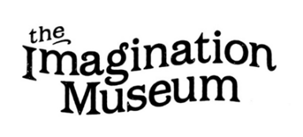
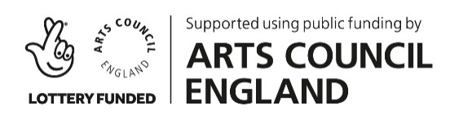
The Imagination Museum Co-commission 2026-7
with Ipswich Museum and DanceEast
Template Application Form
This Word document is intended to provide you with somewhere to prepare your answers to the questions on the Google Form here: https://forms.gle/tTrkR7RyK3qrWNAc9.
When you are ready, please upload your final Stage 1 application via the online form, by 5pm on the 10th July 2026 at the latest.
Full callout information: https://imaginationmuseum.co.uk/eastengland-callout-2026/
About you
- Full name

- Email address

- Phone number (optional)

- Postcode (we only need the first part of your postcode to determine where you are based)

- Please indicate whether you are currently available for the project timeline outlined in the callout (noting that some of the dates are subject to change) | Yes / No
- Please provide any further information about your availability for the project timeline (optional)

Key questions
- Please provide an initial response about why you think you would be a good fit for this opportunity, bearing in mind the themes of the co-commission, proposed participant group and context for the final performance (250 words)

We understand that you can’t tell us everything about how you would respond at this stage, especially in 250 words or 2 minutes of video/audio, so please don’t worry about pitching your idea at Stage 1. Instead use this as an opportunity to tell us a little about what drew you to or excited you about this project, and how you feel your experience matches the brief.
If you want to provide a video response, please provide an online link here (maximum 2 minutes)

You can use a Dropbox, Google Drive, WeTransfer or alternative online link to share your video or audio file with us, but please make sure that if it is password protected you also provide details of the password.
If you want to provide an audio response, please provide an online link here (maximum 2 minutes)
- Please provide details of your previous experience working with dance with community and non-professional groups, including working with children and young people (150 words)

We want to know that artists have experience working with the kinds of groups who will participate in the project as performers and collaborators.
If you want to provide a video response, please provide an online link here (maximum 1.5 minutes)
If you want to provide an audio response, please provide an online link here (maximum 1.5 minutes)
- Please provide a link to your website or other online profile

It will be helpful for us to see some evidence of your previous work and understand how this is relevant to the co-commission brief. Alternatively, you can provide links to one or two specific works in the following question if you would like us to focus our attention on particular projects.

Please note that it may be more effective to signpost us to examples of your practice that are relevant to the theme, context or participants of the co-commission brief in the next question, as we will not be able to spend extensive time browsing applicants' websites during the assessment process.

Alternatively, please provide links to or brief information about one or two examples of individual works/previous projects that you feel are relevant to this brief.

About the application process
- Please tell us how/where you found out about this opportunity (please tick all that apply) | - via Imagination Museum social media accounts  - on The Imagination Museum website  - in an Imagination Museum email newsletter  - I attended an Imagination Museum Advocacy Event in 2024  - via DanceEast socials, website or other  - via Ipswich Museum socials, website or other  - other online listing/opportunities noticeboard  - recommendation/referral from a friend/colleague  - online search  - other
- Is this the first time you have heard about The Imagination Museum dance/heritage network? (please tick all that apply) | - Yes  - No, I was already familiar with The Imagination Museum  - No, I was already familiar with The Imagination Museum and have engaged with previous events or activities (online or in-person)  - Other
- Please comment on the ease of applying for The Imagination Museum Co-Commission, using a scale of 1 to 5

- Is there anything else you would like us to know about your experience of applying for The Imagination Museum Co-commission?

You will not be able to save and return to your form responses, so we recommend you prepare your answers in advance, and then submit all of the information in one go. You can use a Dropbox, Google Drive, WeTransfer or alternative online link to share any video or audio files, but please make sure that if it is password protected you also provide details of the password. If you encounter any technical issues with the form, please let us know at manager@imaginationmuseum.co.uk and we will do our best to resolve them.

