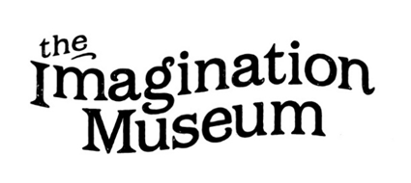
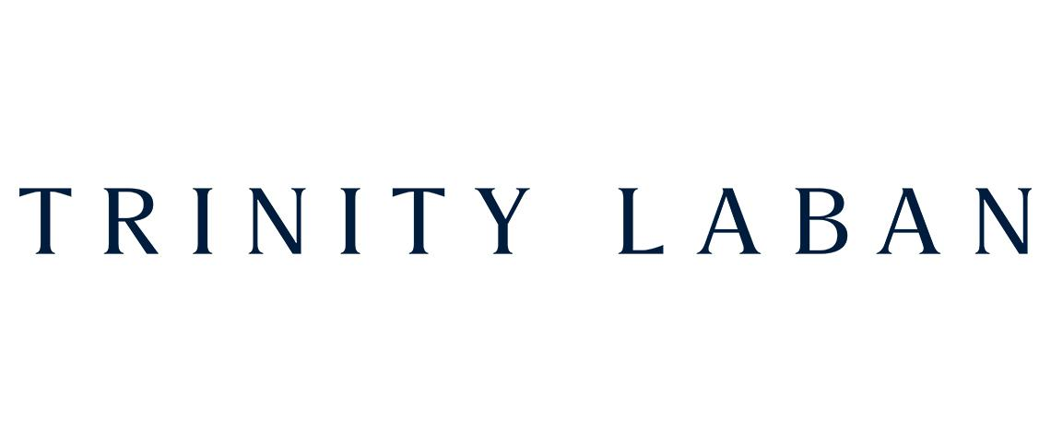
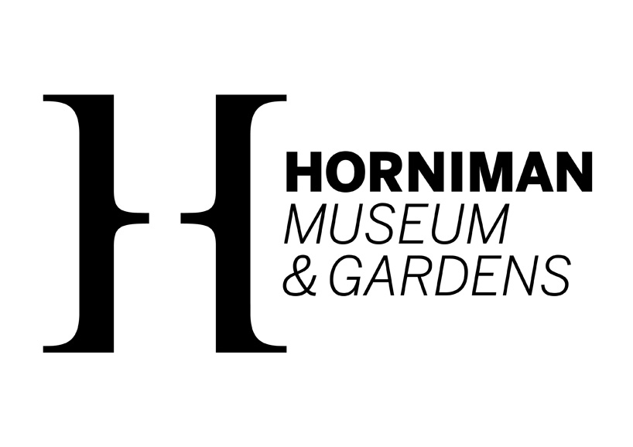
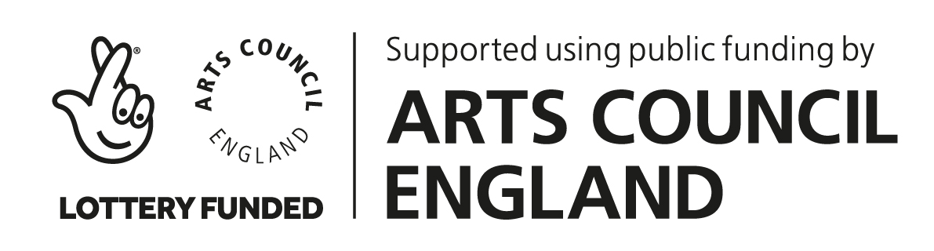
The Imagination Museum Co-commission 2026-7
with the Horniman Museum and Gardens and Trinity Laban

Contents:
Overview 1
What is The Imagination Museum? 2
Context for The Imagination Museum Co-commissions 2
The Horniman Museum & Gardens & Trinity Laban co-commission: more information 3
Supplementary information about the Horniman, and Nature + Love 4
Project timeline 5
Essential skills/experience 6
How to apply 7
Contact details and links 8

Overview

Supported with funding from the National Lottery through Arts Council England, the Horniman Museum and Gardens and Trinity Laban, The Imagination Museum dance and heritage network is pleased to announce a £6,000 co-commission for a London-based dance artist/s to create an original work in response to the collections of the Horniman Museum and Gardens in London.

The selected artist/s will work collaboratively with participants from Trinity Laban’s adult and community dance programmes, who will also perform in the finished work. Final performances will take place in April 2027, on-site at the Horniman, including using some of the new areas in the Horniman Gardens (weather-dependent).

The following callout outlines the parameters of the commission in greater detail, but here are some key points to bear in mind when making a decision about whether to apply:

- This callout is open to artists working primarily with dance/movement as part of their practice, with at least 5 years of professional experience. We welcome applications from artists working within all forms and genres of dance, who use a range of choreographic processes.
- We recognise the unpaid time artists invest in putting together applications. We are therefore using a two stage process so that only the artists whose skills and experience represent the best match with the project (based on the information they provide at Stage 1 and a scoring process completed by a panel including representatives from The Imagination Museum and co-commissioning partners) will be invited to spend their time on a Stage 2 application.
- The deadline for Stage 1 applications is 15th May at 5pm. Artists progressing to the next stage will then need to submit a Stage 2 application by the 19th June at 5pm. Shortlisted artists will be invited to attend an interview on the 16th July at the Horniman Museum.
- You can submit your responses to the Stage 1 and 2 questions in writing, or as a film or audio recording.
- Shortlisted artists will receive a fee of £100 and travel expenses to prepare for/attend the interview, and will receive the interview questions and other information about the venue and the interview panel in advance.
- We conceived this project as an opportunity for an individual dance artist given the scale of the fee and the scope of what it entails. Small groups/companies/ partnerships are welcome to apply, but must consider carefully how this would work in practice, as there are no additional fees available for multiple artists working together.

We encourage you to get in touch (contact Charlotte on manager@imaginationmuseum.co.uk) to discuss any access needs and if there is anything further we can do that would make applying easier.
______________________________________________________________

What is The Imagination Museum?

The Imagination Museum is a national network for dance, community and heritage sector professionals. Through online and in-person events and resources, we share extensive knowledge and experiences and facilitate opportunities for future collaboration across the country, making the case for the benefits of dancing in museums and heritage sites. For more information about the network, please visit https://imaginationmuseum.co.uk/about/.

Context for The Imagination Museum Co-commissions
This is a pilot project from The Imagination Museum network exploring how museums and heritage sites can work with dance artists to co-create new work with local communities. Funded by the National Lottery through Arts Council England, the project is about testing ideas, learning together, and shaping a model for future collaborations.
Because this is a first step, some parts of the project will evolve as we go. We’re looking for artists who are open to experimenting, reflecting on the process, and helping us learn what works.
This callout for London-based artists to work with the Horniman Museum and Gardens and Trinity Laban is the first of two. The second, which is being offered in partnership with Ipswich Museum and DanceEast will be announced later in the year, in early June 2026.
We invite you to sign up to The Imagination Museum mailing list via the Join In page here: https://imaginationmuseum.co.uk/join-in/ or follow the network on socials (Instagram: https://www.instagram.com/imaginationmuseum/ Facebook: https://www.facebook.com/TheImaginationMuseum ) to receive up to date information.

The Horniman Museum and Gardens and Trinity Laban co-commission: more information
The Horniman Museum and Gardens and Trinity Laban have an extensive track record of collaboration, working together on an exciting range of projects since 2009, including the ‘Object in Focus’ programme, which has seen Trinity Laban ‘hosting’ objects from the Horniman collection in their building, the Curious Tea Party event in 2014, pop-up performances and flash mobs linked to events and festivals and co-commissioning of work by professional artists.
Theme/starting point
The Imagination Museum co-commission for the Horniman will respond to the ‘Nature + Love’ Project, a transformational project aiming to inspire a greater understanding and appreciation for the world we all share.
Through new displays, destinations and programmes across the Horniman, the museum will encourage people to connect with nature in ways which work for them, make the Horniman more sustainable, accessible and inclusive, recognise the impact of the climate and ecological emergency, and help to protect and celebrate the natural world.
The completion of Nature + Love in early 2027 will round off the Horniman’s celebrations of 125 years since the Museum first opened in 1901.
Find out more about the project here: https://www.horniman.ac.uk/project/nature-love/
We are inviting the commissioned dance artist/s to create a piece that actively connects people with nature and with the living collection at the Horniman, inspiring them to love and protect the natural world around them.
Celebration event/s
The final shape of the performance work created in response to this co-commission will be developed collaboratively by the selected artist working with community groups and partners, but we expect final performances to take place as part of the Horniman Museum and Gardens’ Spring Fair in 2027 (April 3rd or 10th 2027 tbc).
We intend the final performances to happen outside (weather dependent), potentially using some of the new spaces in the museum gardens such as the new nature themed play area, sustainable gardening zone, and community garden. However, there may also be opportunities to use other areas inside the museum, subject to future discussion.
Working collaboratively with local people
The selected artist/s will collaborate with two of Trinity Laban’s adult community groups as performers in the final co-commissioned work. These groups will be made up of adults who attend regular sessions at Trinity Laban including adults aged 18 – 55, participants aged 60 and over and those with disabilities. These groups provide an inclusive environment, welcoming both beginners and more experienced dancers.
The main devising and rehearsal period will take place from January - March 2027, over the course of approximately 12 weekly sessions as indicated in the schedule below.
The successful applicant will receive:
- A fee of £6,000.

Any travel, access, materials/props, and costs of sourcing/creating music need to be included in this fee. No additional costs can be claimed.
- Production support from co-commission partners and The Imagination Museum team e.g. links with groups, support accessing space for rehearsal.
- A choreographic assistant to support weekly rehearsal sessions as needed.
- 3 online artist coaching sessions (with creative movement practitioner/researcher and dance/museums specialist Sara Wookey)
- Film/photographic documentation of the work-in-progress and final celebration performances, to be arranged and paid for by The Imagination Museum.

Supplementary information about the Horniman, and Nature + Love
We have compiled some more information, with images, describing the:
- developments taking place at the Horniman as part of the Nature + Love project, including areas of the garden and inside the museum building
- Horniman Spring Fair
- history of the Horniman collection and some example objects
in the supplementary document available here.
Please contact The Imagination Museum at manager@imaginationmuseum.co.uk if you require this information in another format.
This document indicates some of the many possible ways to interpret this brief, drawing on the history of the site, people’s more personal connection with nature in their local area or linking with global perspectives on sustainability and climate change for example. Although there would be much more to discover and plan once the commissioned artist was in place, we are interested to hear from artists:
- at Stage 1 - about what draws them to this opportunity, and how their experience meets the brief
- at Stage 2 - about what their first thoughts would be in responding to the brief.
Applicants are not expected to do any additional research beyond what can be found in this callout and the supplementary information when applying for this opportunity.
_________________________________________________________________________

Project timeline
Please note that the schedule for the project may be subject to change.
13th April 2026 | Announcement of artist callout
11th May 2026  12-1pm  (with 30 minutes time for additional questions at the end, for anyone who would like to stay) | Online lunchtime Q&A with the Horniman Museum and Gardens/Trinity Laban, via Zoom  An opportunity for interested artists to hear more about the co-commission and ask any questions.  Please book your place here to receive the Zoom link when it is available.  The online sessions will also be recorded and made available via the Imagination Museum website. Make sure you join The Imagination Museum here and follow the network on socials (Facebook: https://www.facebook.com/TheImaginationMuseum and Instagram: https://www.instagram.com/imaginationmuseum/) if you want to be notified when the recordings are available.
15th May 2026 at 5pm | Stage 1 deadline for submitting Expression of Interest
By 4th June 2026 | Selected artists will be invited to make a Stage 2 application Further information will be provided about the questions being asked at that stage, and what the panel are looking for in artists’ responses.
19th June 2026 | Stage 2 application deadline
16th July 2026, before 3pm | Interviews for shortlisted artists, in person at the Horniman Museum and Gardens. Further information about scheduling will follow. We will provide interview questions in advance, information about the venue and how to get there, and who will be present on the interview day.  Shortlisted artists invited to interview will receive a fee of £100 + travel expenses.
By 24th July 2026 | Deadline for informing selected artist/s
Sept/October 2026 | Commissioned artist/s meeting with partners and finding out more about the Nature + Love project, including the collection and new outdoor spaces; initial exploratory workshop/s with community groups, or representatives of those groups.
w/c 11th January - w/c 22nd March 2027 | 12 weeks or equivalent main creation/rehearsal period  Participating community groups would meet weekly on a week day but we will also add in some weekend additional extended rehearsals.
Dates tbc | Final rehearsal on-site (provision will be made for outdoor/indoor options for rehearsals as necessary)
3rd or 10th April 2027 tbc | Celebration performances, part of Spring Fair
End of September 2027 | Documentary films and final evaluation completed

Essential skills/experience
Co-commissioned artists will:
- Work primarily with dance / movement as part of their practice. We welcome applications from artists working within all forms and genres of dance, who use a range of choreographic processes.
- Have an established choreographic practise of at least 5 years, currently creating dance work within the professional and/or community sector, with experience working site-responsively.
- Be over 21 and able to work in the UK, registered as self-employed with a UTR number.
- Have experience working with a broad range of adult community groups with diverse needs and abilities and a solid understanding of best practice, supporting participants to contribute to development of a project and ensuring their thoughts are heard and reflected in the project content.
- Have an up to date Enhanced DBS Check already in place, Public Liability Insurance (limits of indemnity minimum £2 million), solid understanding of safeguarding and the importance of creating a positive empowering environment conducive to participants’ mental health and well-being.
- Be professional, friendly, organised, with experience managing relationships with multiple kinds of partners and responding to a range of sites
- Be willing to feed into overall project evaluation to ensure learning from the project can be shared more broadly.
The Imagination Museum, Horniman Museum and Garden and Trinity Laban are committed to creating a culture in which diversity and equality of opportunity are promoted actively and in which discrimination is not tolerated. We welcome applications from dance artists of global majority heritage**, who identify as LGBTQIA+, D/deaf, disabled, neurodivergent and groups of people who have been traditionally under-represented in the arts.
You can find more information about Equality, Diversity & Inclusion at Trinity Laban here
and read more about the Horniman’s:
- Equity, Diversity and Inclusion Policy and Framework
- Access Advisory Group and about
- Accessing the Horniman site itself.
**By global majority heritage we mean: People who identify as having full, partial or mixed heritage/s from indigenous peoples of the global south, the African Diaspora, SWANA (South West Asian - sometimes referred to as 'Middle Eastern' - and North African) region and/or who may describe themselves as dual or mixed heritage, Black, Brown, South Asian, Latinae, East and South East Asian (ESEA).
We understand that not everyone uses the same terminology in this sphere and in our communications we aim to embrace the verbal or written language dancers prefer to use to describe themselves and their identities.
________________________________________________________________________

How to apply
You can submit your Stage 1 Expression of Interest for this opportunity using the following online form: https://forms.gle/8S6DoCKVV1G3ouTB6
In this form you will be prompted to provide:
- Contact information
- Confirmation of your availability for the project timeline (and any relevant notes on your availability during that time)
- An initial response about why you think you would be a good fit for this opportunity, bearing in mind the themes of the co-commission, proposed participant group and context for the final performance (250 words, or 2 minutes of video, or 2 minutes of audio)
We understand that you can’t tell us everything about how you would respond at this stage, especially in 250 words or 2 minutes of video/audio, so please don’t worry about pitching your idea at Stage 1. Instead use this as an opportunity to tell us a little about what drew you to or excited you about this project, and how you feel your experience matches the brief.
- Details of your previous experience working with community and non-professional groups, particularly adult community groups (100 words, or 1.5 minutes of video, or 1.5 minutes of audio)
- 2 examples of individual works, or one link to your website or alternative online profile that you feel are relevant to this brief
You will not be able to save and return to your form responses, so we recommend you prepare your answers in advance, and then submit all of the information in one go. You can use a Dropbox, Google Drive, WeTransfer or alternative online link to share any video or audio files, but please make sure that if it is password protected you also provide details of the password. If you encounter any technical issues with the form, please let us know at manager@imaginationmuseum.co.uk and we will do our best to resolve them.

Your responses should be submitted online via the form link here: https://forms.gle/8S6DoCKVV1G3ouTB6 by the 15th May 2026 at 5pm.
- Selected artists will then be invited (notified by the 4th June 2026) to make a Stage 2 Application to provide some more information about their initial ideas, which will supplement their initial Expression of Interest.
- The deadline for Stage 2 applications will be the 19th June 2026 at 5pm
- Shortlisted artists will be invited to attend interviews on the 16th July before 3pm at the Horniman Museum. If this is the case, we will aim to give at least 1 week’s notice.
Assessing applications
Stage 1 Expressions of Interest will be reviewed by a panel including representatives from The Imagination Museum and co-commission partners, and scored against the following criteria:
- Availability for the project timeline - yes/no
- Relevance of artist’s practice, portfolio and initial response to the commission brief and audience (70%)
- Relevant experience of working with a commissioning organisation or similar (30%)
It is very important to us that the application process should not form a barrier to you applying for this co-commission, so please contact us (manager@imaginationmuseum.co.uk) if you need any of the callout information provided in a different format, or if you want to provide the information requested in our application form in another format.
Remember, please submit your Stage 1 Expression of Interest online via the following link: https://forms.gle/8S6DoCKVV1G3ouTB6 by 5pm on the 15th May 2026.
_________________________________________________________________________

Contact details and links
Please contact us at manager@imaginationmuseum.co.uk with questions regarding the application process, but note that we cannot answer questions about the content of specific proposals. If you encounter any technical issues accessing this email address, please contact Strategic Lead for The Imagination Museum, Katie Green, on katie@madebykatiegreen.co.uk as an alternative.
We will endeavour to provide feedback to any artists who progress to interview, and will offer reflections on the overall commissioning process on The Imagination Museum website after artists have been selected, but unfortunately, due to the capacity of our team, we will not be able to provide feedback at other stages of the application process.
Remember, you can sign up to join our online Q&A session on the 11th May, 12-1pm (with an optional additional 30 minutes), to find out more about the project:
https://www.eventbrite.co.uk/e/zoom-qa-for-artist-commission-with-trinity-laban-and-the-horniman-tickets-1985707635993

Useful links
For more information about the co-commission partners, please visit their websites:
The Horniman Museum and Gardens - https://www.horniman.ac.uk/
Trinity Laban - https://www.trinitylaban.ac.uk/
Click here for more information about The Imagination Museum.
You may be interested to look through some of the dance/heritage Case Studies on The Imagination Museum website for ideas and inspiration, and we have an Essential Read available here with some guidance for getting started working with dance and movement in museums.
The Imagination Museum Co-commissions 2026-7 are being supported financially using public funding from the National Lottery through Arts Council England, the Horniman Museum and Gardens, Trinity Laban, Ipswich Museum, DanceEast and also by Made By Katie Green, current managing organisation for The Imagination Museum dance/heritage network.

